**LAB 1**

Q1: Find the roots of a quadratic equation.

**Algorithm –**

1. Start
2. Take three coefficients a,b,c as input and store them in respective variables.
3. Initialize d = b^2 – 4*a*c
4. Initialize e = b/(2*a)
5. Check if d > 0 Go to Step 6 else Go to Step 8
6. R1 = e + (sqrt(d)/(2*a)) R2 = e - (sqrt(d)/(2*a))
7. Print R1 and R2. Go to Step 13
8. Else Check If d == 0 Go to Step 9 else Go to Step 11
9. R1 = -e and R2 = -e
10. Print R1 and R2. Go to Step 13
11. d = -d , im = sqrt(d)/(2*a)
12. Print R1 = e + ‘I’ im and R2 = e – ‘I’ im
13. End

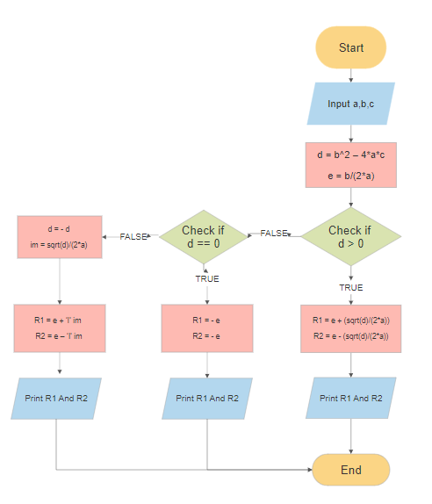

**SPARSH CHADHA**

**E18CSE179**